Elm Tree Matters – May 2025

PAY DAY / TIMESHEETS
HEALTH CAMPAIGNS
SKIN CANCER AWARENESS MONTH
https://www.macmillan.org.uk/cancer-awareness/skin-cancer-awareness-month
STROKE AWARENESS MONTH https://www.stroke.org.uk/stroke-awareness-month
DYING MATTERS AWARENESS WEEK
5th – 11th May 2025
https://www.hospiceuk.org/our-campaigns/dying-matters/dying-matters-awareness-week
MENTAL HEALTH AWARENESS WEEK
12th- 18th May 2025
https://www.rethink.org/campaigns-and-policy/awareness-days-and-events/mental-health-awareness-week/#:~:text=Mental%20Health%20Awareness%20Week%20is,severely%20affected%20by%20mental%20illness.
DEMENTIA ACTION WEEK
19th- 25th May
https://www.alzheimers.org.uk/get-involved/dementia-action-week

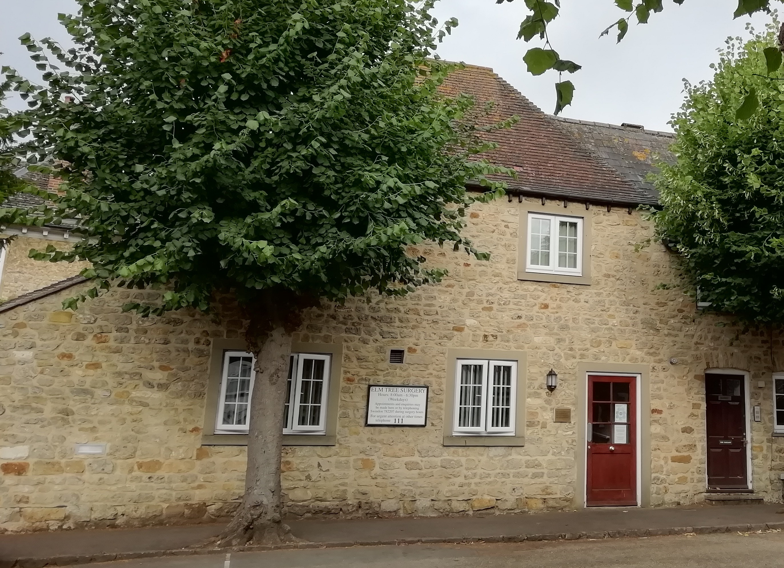

Pay day will be Friday Monday 30th May 2025 , the timesheets and any claim form deadlines will be Monday 26th May 2025.
BUILDING UPDATES
Sadly, no news on premises we are continuing to look what is coming on the market and remain hopeful for a amazing piece of land or a lovely large building with free parking.

CLINICAL ROOMS
Just a reminder can everyone please leave clinical rooms as they find them. We have had several reports that rooms have been left in disarray at the end of the session and when the clinician comes in the next morning they must clear before they can start seeing patients.
Some examples are blue roll thrown on floor, urine samples left on sinks.

CALL AUDIT
We will be completing a full call audit as we have received some concerning feedback that some staff members are advising patients to call back on certain days so they can get an appointment with their preferred GP as they are working as Duty GP .This we are sure you will agree in unacceptable and not what the Duty GP is there do . Once staff members are identified we will discuss our sincere concerns about this as its is creating problems for patients who need same day medical appointments.
ANNUAL LEAVE
Just to remind everyone that clinical annual leave needs to be sent to Lesley . Rota’s are added to the clinical system every 4-6 weeks so please ensure leave is requested in a timely manner .
Reception annual leave is overseen by Sandra and requests are made via request sheet .
We are looking at moving to online annual leave requests via TeamsNet

RECEPTION AREA
Just a ongoing reminder we have received feedback from patients that reception conversations can be heard in waiting room area.
We have observed this ourselves by sitting in reception and listening to staff discussing other staff Can everyone please be mindful of discussions in reception and the content of the discussions.
If we have nothing good to say please say nothing.
Please be kind to each other , everyday we deal with cross, frustrated and worried people which is draining .
If you are worried how you colleagues are doing something please speak to Jane .

APPOINTMENTS
Just a reminder one appointment one problem please and mental health appointments are double appointments slots.
We have seen an increase in embargos being used.
When booking same appointments can we please book in date order of slots , we understand that there maybe exceptions however many are booked to out of order which causes issues with appointment availability later in the day .

DISPENSARY
Please could all dispensers remember to date CD requisition forms when completing them. It is very difficult to file them in the relevant order without a date.
Please could all clinicians remember that often we must order medication in from dispensary so if needed immediately please check formulary.
We are also looking at moving to Electronic prescriptions using a software package called Titan , please watch this space.
https://www.titanpmr.com/repeat

E-CONSULTING AND DOCUMENT PROCESSING
We are continuing to explore online consultation options and Francis is taking the lead on this, there are many different options on the market and Francis is reviewing the different options for us for triage and document processing management.
https://www.rapidhealth.ai/st
https://www.youtube.com/watch?v=Q0oft_e22nA

Policy reviews
Please don’t forget to keep checking the policy file for updates and making sure your up to date with our policies and local protocols. S:\ELM TREE SURGERY\Shared\Policy and Procedures.
We have recently reviewed our information governance policy .
Anyone who has problems accessing these then please let Jane know.

CQC
Monthly reminder that the CQC will be visiting shortly as we are due a CQC inspection.

Francis, Abby, and Laura

